


Operating system version iOS 26.5
Migration iPhone/iPad
DB Workplace Mobile

DB Systel GmbH | 04 June 2026
Table of contents
1 The migration process at a glance 3
2 Start migration 4
2.1 Authenticator app – optional 4
2.2 Creating a Temporary Access Pass (TAP) – Expert mode 4
2.3 Start migration immediately after the notification 5
2.4 Start migration for a later migration period 5
2.5 Start migration during the migration period 6
3 Registering your iPhone/iPad with DB 7
3.1 Perform configuration 7
4 Create a temporary access pass (TAP) 8
4.1 Create a temporary access pass (TAP) 8
4.2 Create a temporary access pass for a colleague 11
5 Activate device: Company Portal app 13
5.1 Set up access to all DB apps and websites 14
5.2 Set up email encryption 16
5.3 DB apps 17
6 Configuring settings on your device 18
6.1 Install iOS operating system updates 18
6.2 Set up Outlook / Create an email account 19
6.2.1 Setting up an email signature 19
6.2.2 Encrypting emails 21
6.3 Set up the Microsoft Defender app 22
6.3.1 Grant permissions 23
6.4 Reactivate the Microsoft Authenticator app 24
6.5 Notes on using apps 24
6.6 Backing up files 25

The migration process at a glance
The entire migration process to DB Workplace Mobile is summarised here:
 | Technical migration preparation  - Reminder email one day before the scheduled date, confirming that the migration can begin
 | Personal migration preparation  - Take screenshots or make notes of your specialist apps; these will need to be downloaded again  - If you use the Authenticator app:  > see section 2.1 Authenticator app – optional
 | Start migration  - After receiving the migration email:  The following day, a notification will appear on your  iPhone/iPad  > see Chapter 2 Start migration
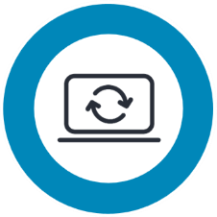 | Migration to DB Workplace Mobile  - Create and make a note of the temporary access pass (TAP)  > see Chapter 4: Create a Temporary Access Pass (TAP)  - Activate the iPhone/iPad Microsoft Intune Company Portal app, or Company Portal app for short  > see Chapter 5: Activate device: Company Portal App  - Any iPhone/iPad that has not been migrated during this period must be restarted after the expiry date – and in some cases restored. This may result in the loss of work and personal data
Important!
Your iPhone/iPad is not yet connected to
DB Management (Intune).
Only enter the temporary access pass (TAP)
in the Company Portal app.
Outlook or Teams are not the right apps for this!
Follow these instructions step by step!

Start migration
You can initiate the migration to the Intune management system yourself, and you can also choose when you want to carry out the migration.
Here’s how it works:
- You will receive an email informing you of the date (e.g. 15 June 2026) from which you can start the migration. The migration period lasts up to four weeks
- The following day, a notification titled “Registration required” will appear on your iPhone/iPad
- You can decide for yourself whether you want to start the migration immediately or at a later date within the migration period

Authenticator app – optional
Note: This information only applies to users who actively use the Authenticator app, for example, for administrative access with a so-called ‘2-account’ or for multi-factor authentication, e.g. for VPN on a Basic Workplace MAC.
- The Authenticator app cannot be used during migration!
- No further steps are required
- After the migration, the app must be reactivated; this is described in Chapter 6.4 Reactivating the Microsoft Authenticator App
- If you need to use the Authenticator app during the migration, use another smartphone or tablet to connect it to the Authenticator app. To do this, follow the step-by-step guide:
> Setting up multi-factor authentication (MFA)

Creating a Temporary Access Pass (TAP) – Expert mode
If you only have a DB iPhone/iPad and can reset your device without assistance, create the Temporary Access Pass (TAP) before resetting it.
> To do this, go to Chapter 4: Creating a Temporary Access Pass (TAP)
- Then start the migration

Start migration immediately after the notification
To start the migration immediately, proceed as follows:
- Tap the notification and then tap “Start registration” in the dialogue box that appears
> Go to Chapter 3: Register iPhone/iPad in the DB
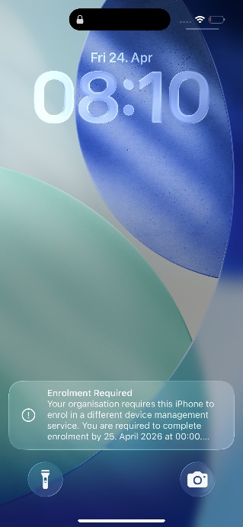 | 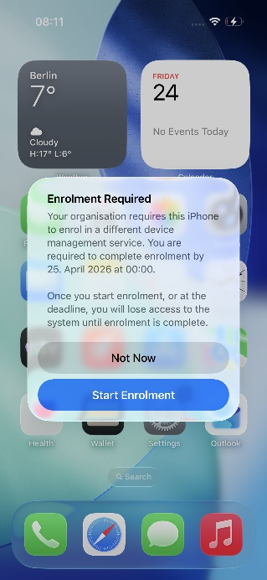

Start migration for a later migration period
If now is not a convenient time for you to migrate your iPhone/iPad, proceed as follows:
- Tap on the notification and then tap “Later” in the dialogue box that appears
- You will see the notification on the home screen of your iPhone/iPad every day until the deadline
> Go to Chapter 3: Register your iPhone/iPad in the database

Start migration during the migration period
If you do not wish to wait for the daily notification but would like to migrate without the notification
proceed as follows:
- Open the Settings app
- Tap on “Registration required” and then on “Start registration”
- Tap “Restart” to restart your device
> Go to Chapter 3: Registering your iPhone/iPad in the DB
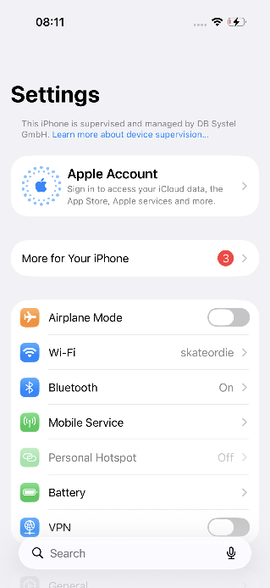 | 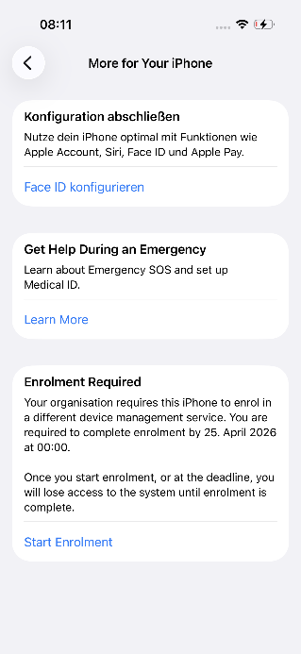 | 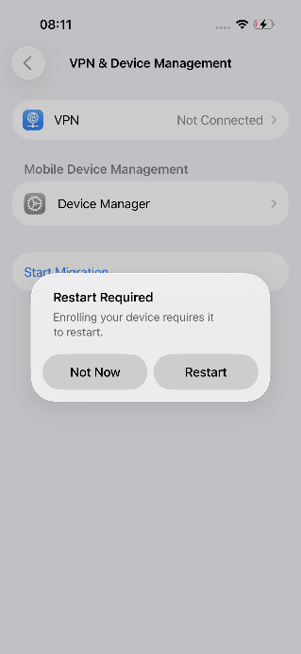

Registering your iPhone/iPad with DB
In the next step, your DB iPhone/iPad must be reconnected to DB Management (Intune).
- Confirm the following prompts by selecting “Register this iPhone”
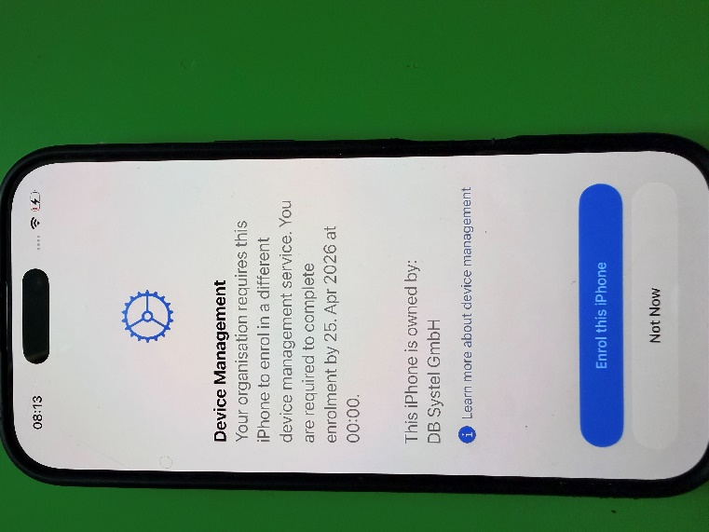

Perform configuration
In this step, your iPhone/iPad will receive the enterprise configuration. This process may take a few minutes.
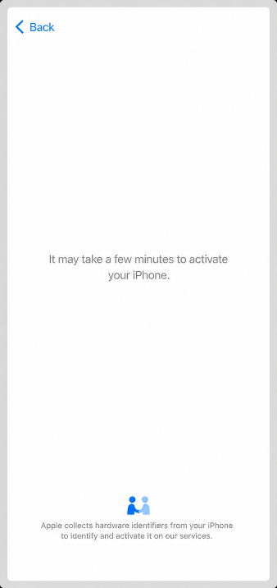
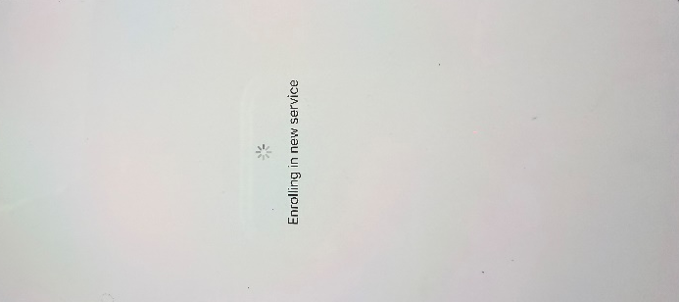
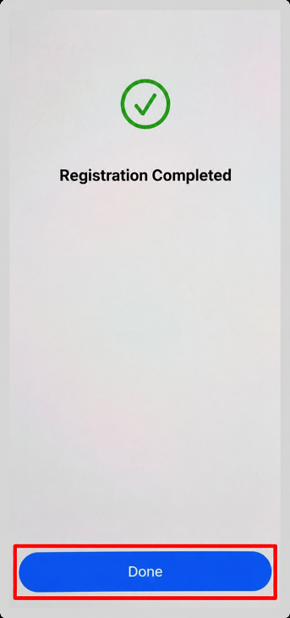
- Then tap “Done”

Create a temporary access pass (TAP)
To set up your smartphone/tablet on the DB Management, you will need the following:
- a valid Temporary Access Pass (TAP) – db.de/tap
- your DB username and DB password
- Microsoft Intune- Company portal app, short Company portal app

For your information:
The DB User is the user account for all employees within the DB Group. It consists of a password of your choice and an automatically generated login name.
> You can reset your DB User password at db.de/passwort
> You can find instructions on how to change your password at Change DB User Password
> You can find out how to obtain your DB User in Prerequisite: DB User
> You can find your DB User name in DeBi at db.de/debi or open the IT ServiceDesk App and tap on “My Profile”

Create a temporary access pass (TAP)
> Note: You can find a video guide at db.de/mobile-videoanleitung
There are several ways to create the temporary access pass (TAP):
Option 1:
You have a second iPhone/iPad or a DB Workplace Windows or Mac device that is already logged into the DB Management. In this case, stay in the current section and continue the next page.
Option 2:
A colleague from the same company (such as DB Sales or DB Long-Distance) can assist you provided they have a DB smartphone/tablet (or iPhone/iPad) or a DB Workplace Windows or Mac. Go to:
> Chapter 4.1 Create a temporary access pass for a colleague
Option 3 – Expert mode:
You only have an iPhone/iPad and were able to use it long enough to create a temporary access pass (TAP) before resetting it. Make a note of your access pass and go to:
> Chapter 5 Activate device: Company Portal app
Note: Your TAP is only valid for 60 minutes and can be used on multiple smartphones/tablets!

Using the Welcome app on your iPhone/iPad, proceed as follows:
- Open the DB Mobile Info app and tap on “Service”
- Then click on “Temporary Access Pass (TAP)” to create it
Via your DB Workplace on Windows or Mac:
- Open your default browser
- Go to db.de/tap and enter your DB username and DB password
- Select “For myself” and tap the blue button
- Now select “DB Workplace Mobile”
- You will then be shown the temporary access pass (TAP)
- This is valid for 60 minutes and can be used on multiple smartphones/tablets
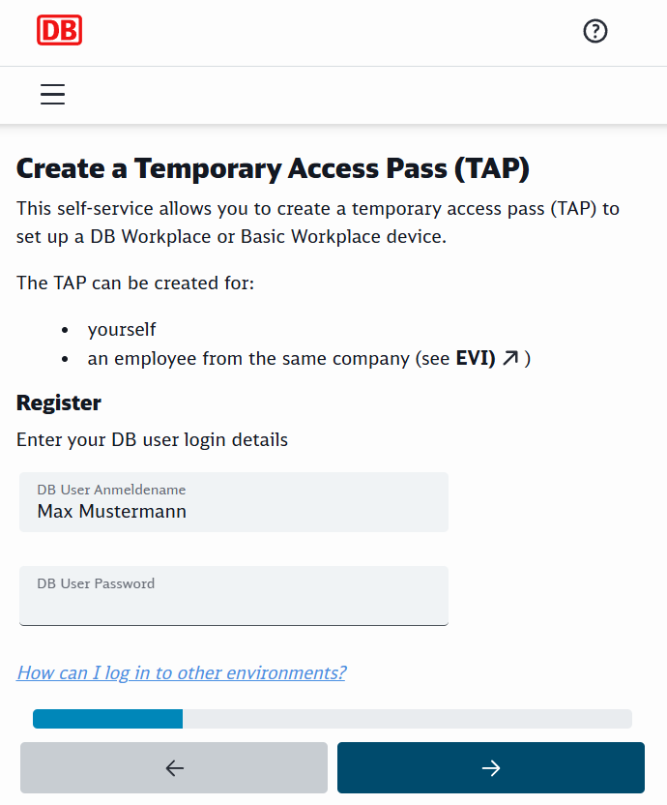 | 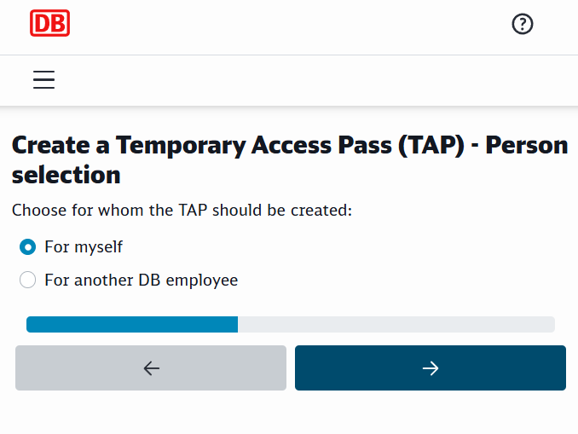
- Write down the temporary access pass (TAP) on a piece of paper or in a notebook
Please note: You will need it later when setting up the company portal app!
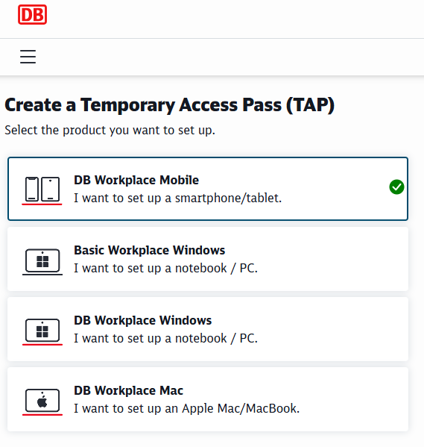 | 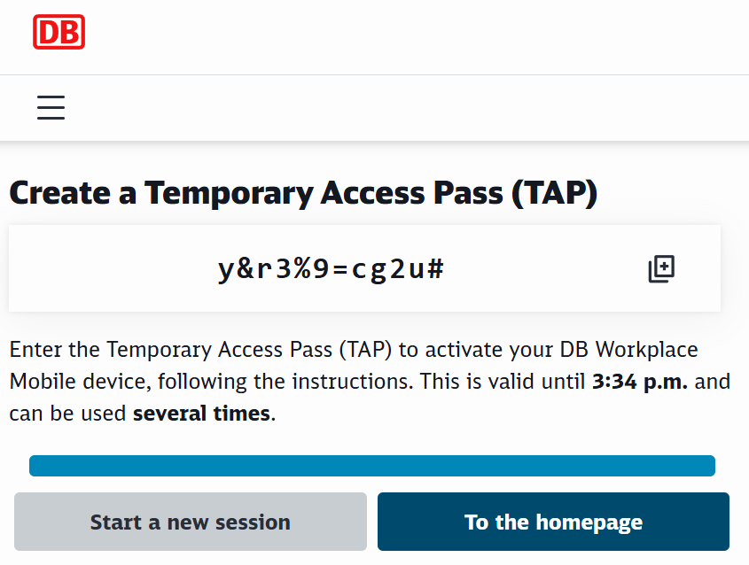
Important!
The TAP may only be entered in the
entered in the
, even if you are asked to do so in another DB app or on another device
- You can now activate your iPhone/iPad in the Company Portal app
> Go straight to Chapter 5: Activate device: Company Portal app
Important!
Your iPhone/iPad is not yet connected to the
DB Management!
Enter the temporary access pass (TAP)
in the Company Portal app.
To do this, follow the step-by-step instructions in
> Chapter 5: Activate device: Company Portal app

Create a temporary access pass for a colleague
To create a TAP for a colleague, follow these instructions:
If you still have the Welcome app installed:
- Open the Welcome App and tap on ‘Help’
- Then click on “Temporary Access Pass (TAP)” to create it
If you have a DB Workplace Windows or Mac:
- Open your default browser
- Go to db.de/tap and enter your DB username and DB password
- Enter your DB username and DB password
- Select “For another DB employee” and click the blue button
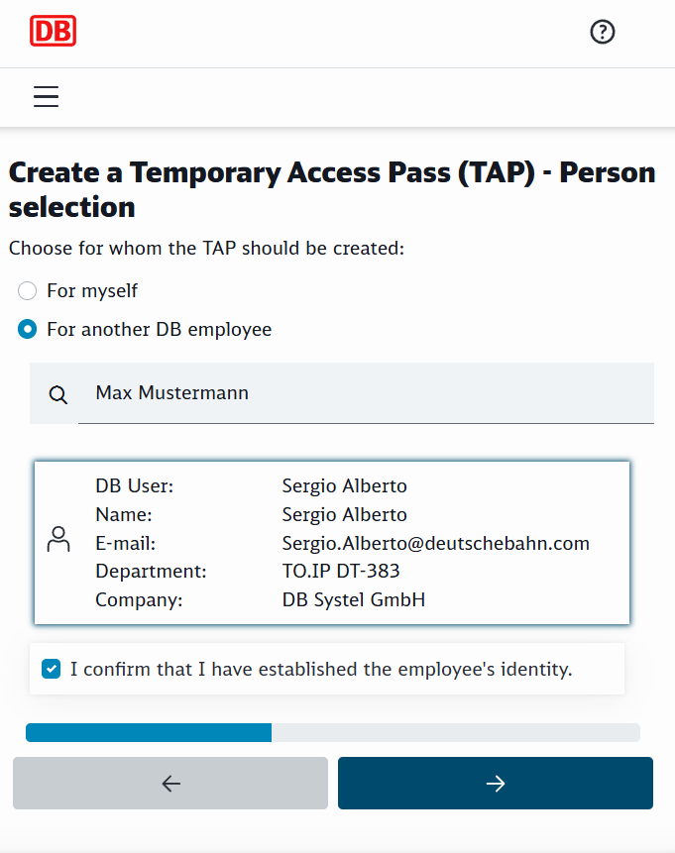

- Select the correct person and confirm their identity
- Hand over control in Teams to the colleague(s) (if working remotely via Teams)
or
- Let the colleague use the computer
- The DB colleague enters the DB user password
- The access pass will then be displayed; it is valid for 60 minutes and can be used on multiple smartphones/tablets
- Take back screen control if you were using Teams

Note: You will need it to set up and activate the company portal app!

- The colleague can now activate their smartphone/tablet in the Company Portal app
> Go straight to Chapter 5: Activate device: Company Portal app
Important!
Your iPhone/iPad is not yet connected to the
DB network!
Enter the temporary access pass (TAP)
in the Company Portal app.
To do this, follow the step-by-step instructions in
> Chapter 5: Activate device: Company Portal app

Activate device: Company Portal app
> Note: Check that you have created and received a temporary access pass (TAP) as described in Chapter 4: Create a temporary access pass (TAP)!
> Note: A video tutorial on this can be found here: db.de/mobile-videoanleitungen
- Open the Company Portal app (Comp. Portal)
- Then tap the “Log in” button
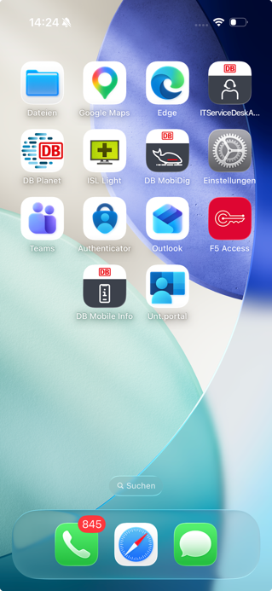 | 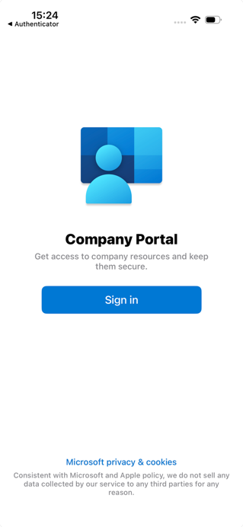
- Enter your DB user email address (not the DB user!) and tap “Continue”
- Tick the box next to “Show temporary access pass”
- Enter your temporary access pass and tap “Log in”
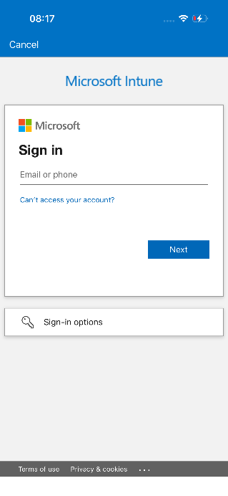 | 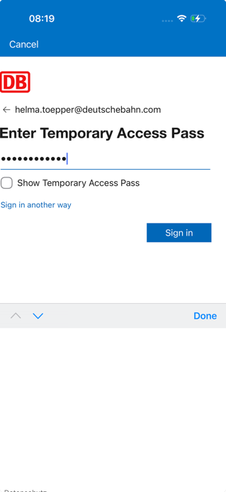

If you receive an error message:
- create a new temporary access pass and repeat the login process as described in Section 4.1 Creating a temporary access pass (TAP)
> Continue to Chapter 5.1 Setting up access to all DB apps and websites

Set up access to all DB apps and websites
Note: It may take between 5 minutes and 1 hour for the certificates to be issued. Only then will you be able to use your apps such as Outlook, Teams, etc.
Important: Follow these steps WITHOUT putting your iPhone/iPad down, otherwise the iPhone/iPad will not set itself up in the Company Portal app and you will not be able to work!
- When prompted to receive notifications, tap “OK”
- Then tap “Allow” in the dialogue
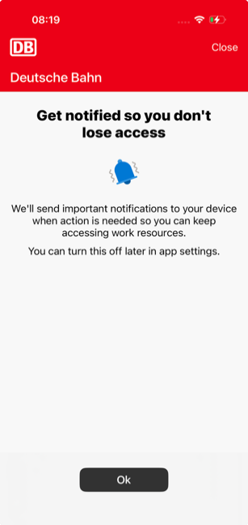 | 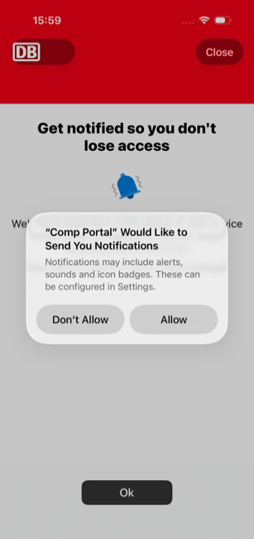

- Tap “Start” to gain access to the DB Management then tap “Continue”
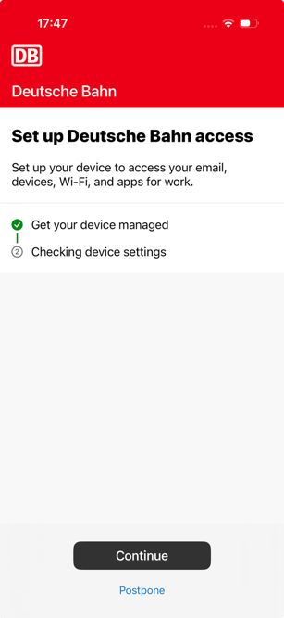
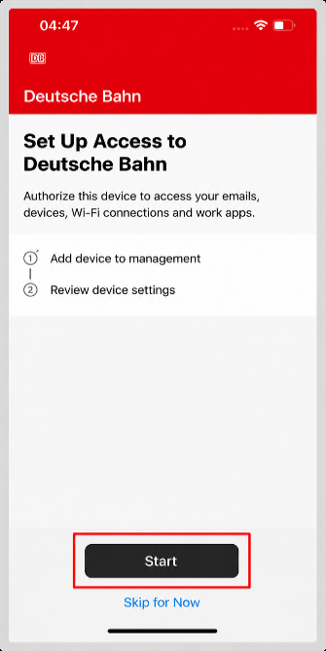

- Tap “Cancel” on the following prompts, then tap “Done”
- Note: The device settings are being checked; please wait a moment!

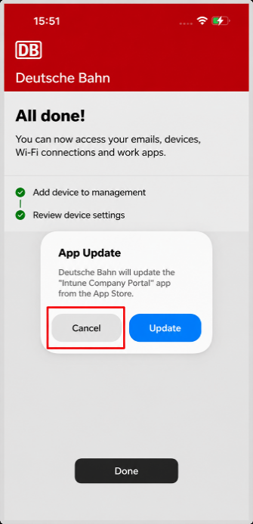 | 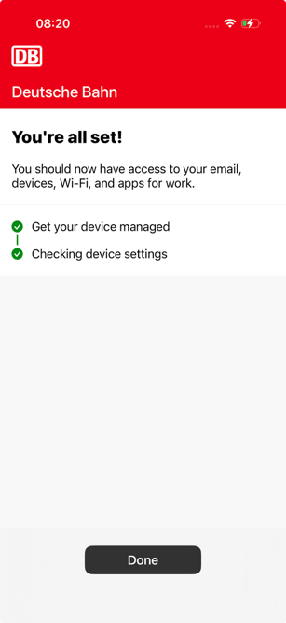 | 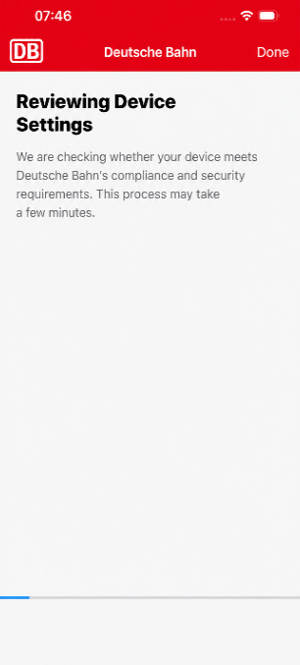
If the update dialogue box appears again, tap “Update”

Set up email encryption
When “All done!” appears:
- Swipe down from the top of the light grey area to refresh the page
- A message will appear regarding the setup of certificates for email signing and encryption
- Tap the message; the certificates will then be loaded and “Setup is complete…” will appear
- Tap “Done”; you can now receive encrypted emails
- You will now see all DB apps that are available for download in the Company Portal app
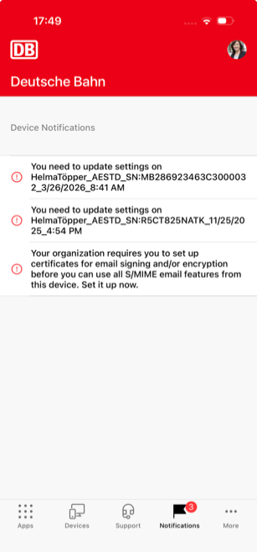   | 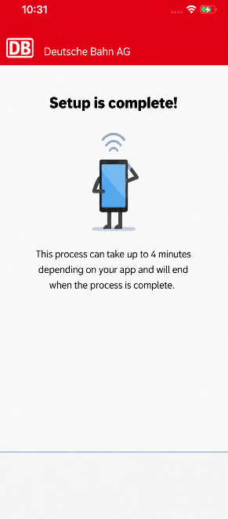
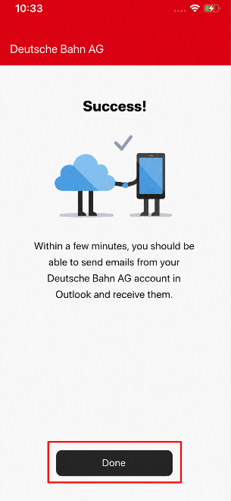 | 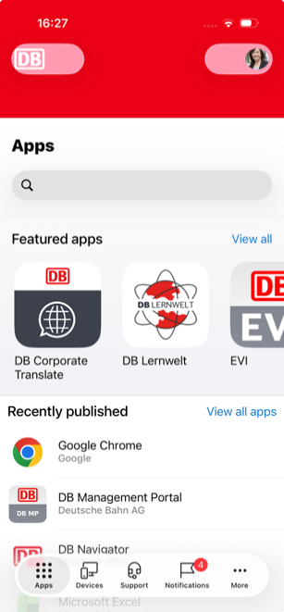

DB apps
Once the migration is complete, Microsoft apps such as Outlook or Teams will be downloaded automatically. Your company-specific or business-specific apps will then be loaded.
- You can download further DB apps from the Company Portal app
- If you use ASES or ATOSS Staff Centre for time tracking, here are the instructions for the key features of ATOSS Staff Centre
- Use Safari as your default browser for web links, such as DB Planet or DB Questions
- Use the DB Password app to save passwords on your iPhone/iPad
- For private apps you need a private Apple ID, enter your private email for this
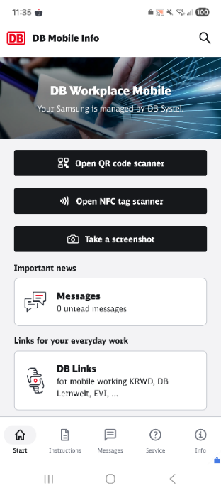
The Welcome app is no longer available on the DB iPhone/iPad; instead, there is the DB Mobile Info app, which contains all the information, useful links and data relating to your DB iPhone/iPad.

Configuring settings on your device
Please note: It may take between 5 minutes and 1 hour for the certificates to be issued. Only then can you use your apps such as Outlook, Teams, etc.

Install iOS operating system updates
- Open the Settings app
- Tap on ‘General’
- Then tap on “Software Update” (new software versions are displayed here)
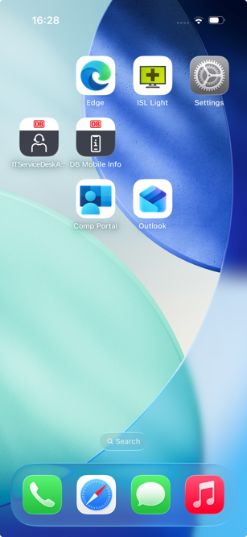 | 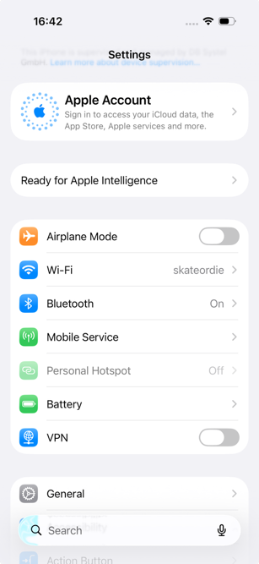 | 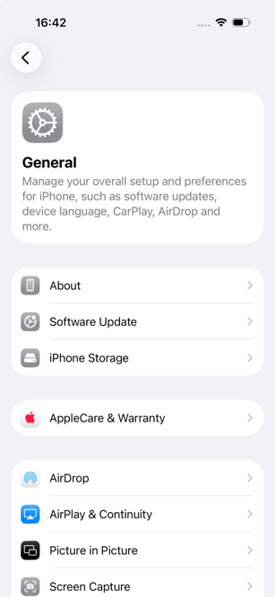
- Enable the “Automatic Updates” feature
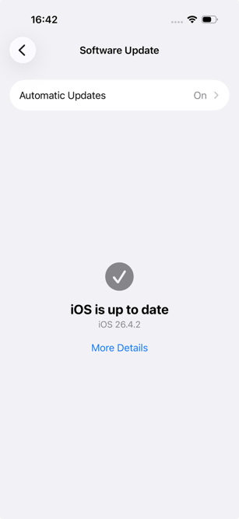 | 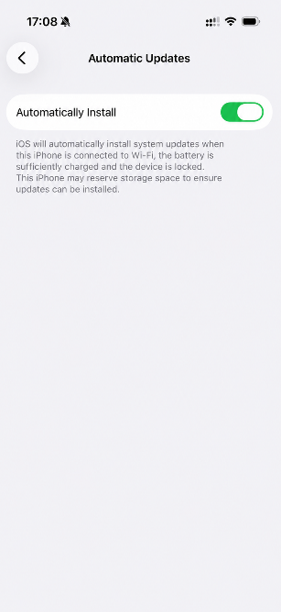

Important:
If a button labelled “Update automatically” appears, tap it and then tap “Download automatically”. The iPhone/iPad will download and install the update; you should be connected to Wi-Fi for this. Otherwise, your iPhone/iPad may not be able to use the DB apps, or the necessary certificates for your iPhone/iPad may not be provided!

Set up Outlook / Create an email account
- Tap the Outlook app
- Your email account should already be set up – tap ‘Add account’
- Select your email address by tapping “Add account”
- Tap “Continue” when prompted for the certificate
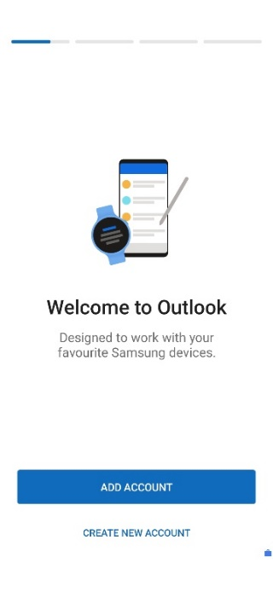 | 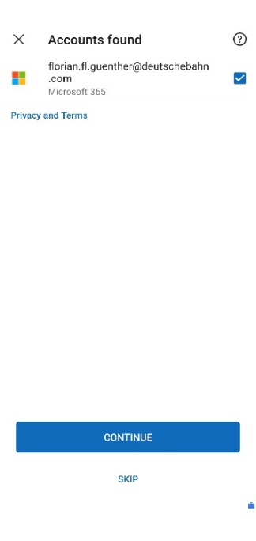   | 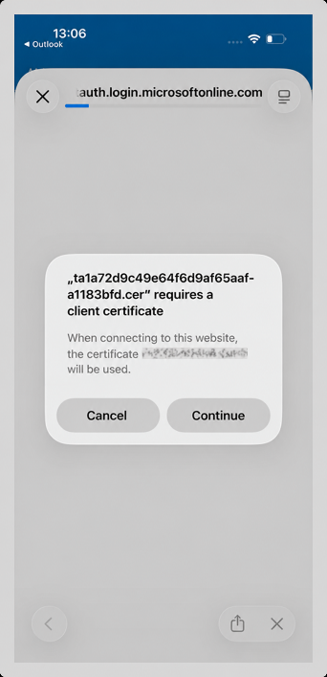
Your email account is now being set up:
- Tap “Maybe later” when asked if you want to add another account
- And tap “No, thanks” to enable notifications
- Your emails are now being loaded (this process may take a few minutes)
- You can then read and write emails again

Setting up an email signature
An email signature is a mandatory part of business communication. It appears at the end of an email and, by law, must contain certain information, such as the company name and the official registered office of your DB company. You can find the text for your email signature in the DB telephone directory, known as the “EVI”.

Here’s how to get your email signature from EVI:

- Open the EVI app
- Tap the three lines in the top right-hand corner next to your profile picture
- Then tap on “My email signature”
- Your personal signature is displayed in the grey field. Copy it by tapping ‘Copy’ at the bottom of the field
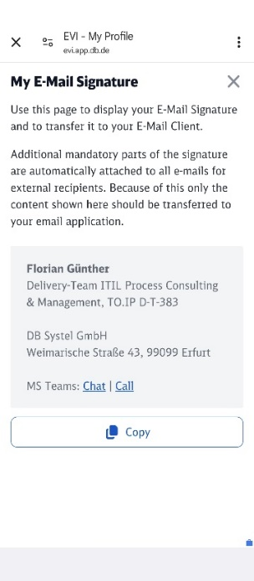

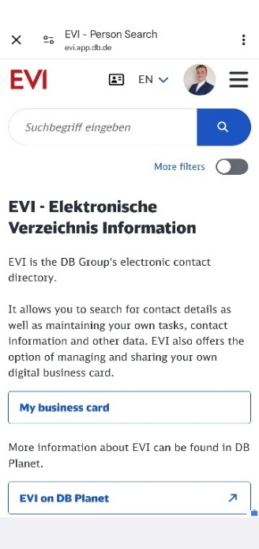
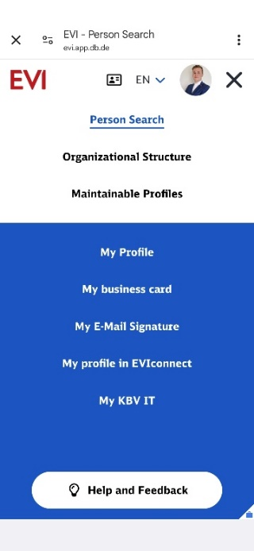

Paste the signature into Outlook:
- Open the Outlook app
- Tap your profile picture in the top left-hand corner, then tap the cog icon in the bottom left-hand corner
- Now tap on “Signature”
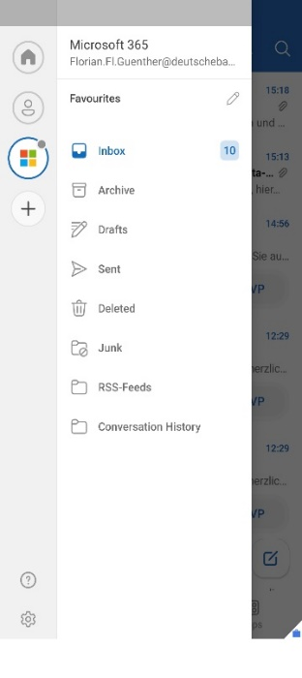
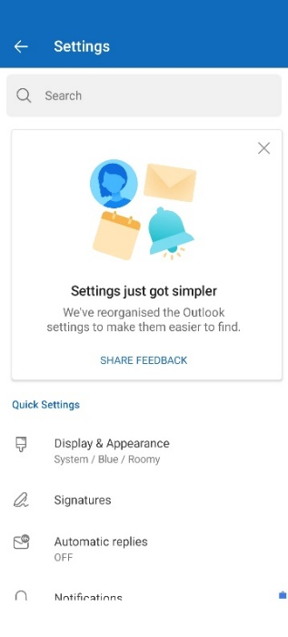
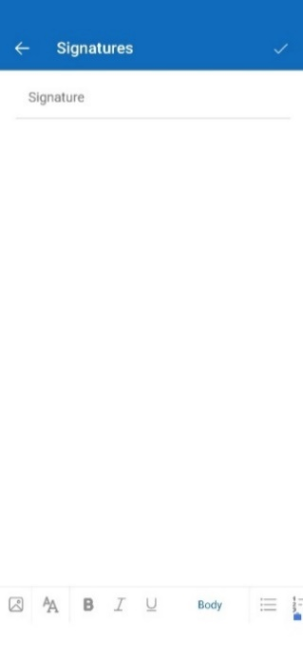

- A field for the signature will open. If there is already an entry there, delete it by tapping ‘ ’
- Now long-press the field until the “Paste” option appears and tap it
- Your signature copied from EVI will be inserted
Close the window – your signature will now be automatically inserted into all emails you write
Note: If you have set up multiple email accounts, you can use the “Signature per account” slider to set up a separate signature for each account. Otherwise, the saved signature will be used for all your email accounts.

Encrypting emails
Emails you send within the DB Group are encrypted by default. This is sufficient for most purposes. You don’t need to do anything else!
However, when sending an email, always bear these two rules in mind:
- The email contains only as much personal data as is necessary
- The subject line of the email must not contain any confidential information
- If you wish to send data requiring special protection (e.g. personnel data) by email, you must also encrypt the content of the email. Outlook offers email encryption.

Setting up encryption:
If you haven’t already set this up for your iPhone/iPad, you don’t need to do anything else. If this is still missing, set up encryption as described in Chapter 5.2 Setting up email encryption.
Email synchronisation – All emails always up to date
All your emails are automatically backed up in the Outlook app and synchronised with your linked Office account. This means that no matter which device you log in from – whether it’s an iPhone/iPad or a BKU computer/Basic Workplace computer – you’re always up to date.

Set up the Microsoft Defender app
The Microsoft Defender for Endpoint Mobile app (MS Defender app) protects your iPhone/iPad from malware, so please set up the app on your iPhone/iPad.
Proceed as follows:
- Hold your iPhone/iPad in portrait mode so that the screens are displayed as shown in the instructions!
- Check that your iPhone/iPad is fully set up and logged into the company portal!
- To do this, open the company portal app and tap “Devices” at the bottom
- If you can see your iPhone/iPad in the overview, it is fully set up
- Go back to the iPhone/iPad home screen and look for the MS Defender app
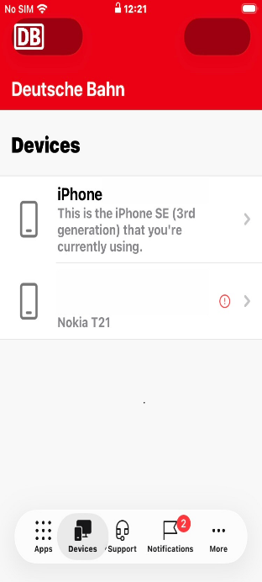
- Tap the MS Defender app icon to open it
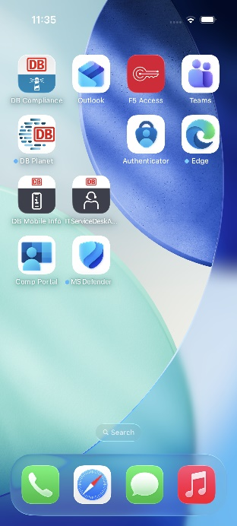 | 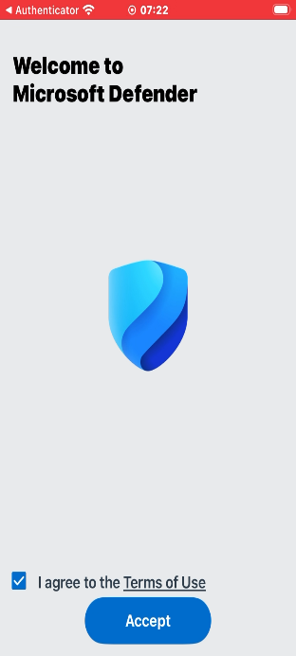  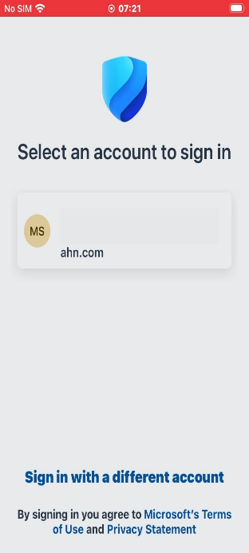
In exceptional cases:
If you are asked for your work email address or if it is already displayed in the list, please tap it or enter it. Then confirm by ticking the box and accept the licence agreement.

Grant permissions
The MS Defender app will now ask you for the necessary permissions. At this point, the screens may appear in a different order to the instructions. If your first screen matches the one shown:
- A prompt to accept a Microsoft certificate will appear
- Tap ‘Continue’ in the window
- A prompt to allow notifications will appear, tap “Allow”
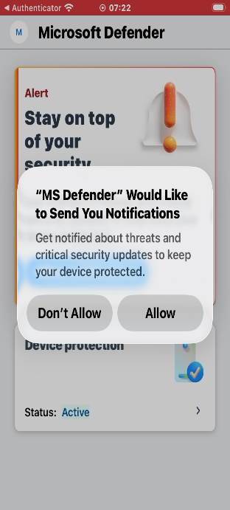  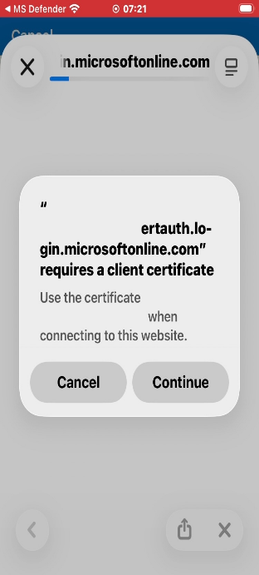 | 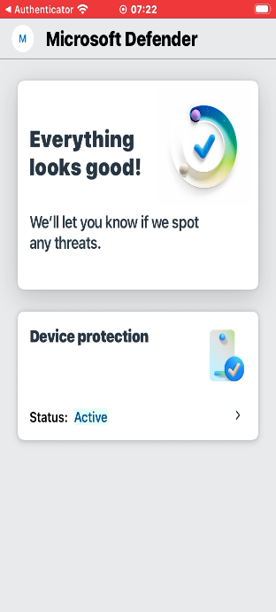
Background information on permissions:
These permissions are required for the app to work properly and to ensure the security of your device. You will then be taken to the MS Defender app’s home screen.
Threat indicators:
- If a green tick is visible, no threat has been detected
- If no green tick is visible, please wait a few hours and restart the app (close the app and open it again)
> If a green tick still does not appear, go to: DB Questions
The iPhone/iPad is now protected against attacks.

Reactivate the Microsoft Authenticator app
If you have been using the Authenticator app, please follow these steps:
- Go to db.de/authenticator on your BKU or Basic Workplace computer
- Tap the ‘plus icon’ and the ‘Add sign-in method’ button
- A dialogue box will open; select “Microsoft Authenticator”
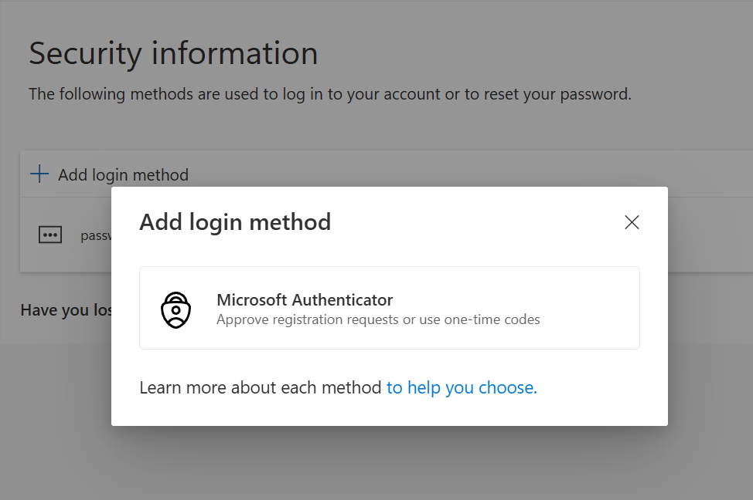
- Switch to your iPhone/iPad and open the Microsoft Authenticator app
- Open this page for step-by-step instructions, tap the “MFA setup guide” button and follow the steps provided
- You can then use the Microsoft Authenticator app for authentication on your iPhone/iPad
- If you have used the Authenticator app for websites or tools, re-enable the app on those websites
Tip: If you have difficulty reactivating the connections in the Authenticator app after the migration, use the self-service option: “Reset Microsoft Authenticator app (MFA)”: db.de/resetmfa and then follow the steps in this section from top to bottom.

Notes on using apps
Messenger
- WhatsApp is not provided via the company portal app and can only be used with your private contacts (private use)
- For work-related communication, use the apps provided via the Company Portal app (e.g. Teams)

Camera
- For work-related photos, use the OneDrive app; this will save photos directly to OneDrive
- The Camera app is for private use only

Backing up files
- Save files, such as PDF documents or images, only in OneDrive, not locally in the ‘Files’ app
- Save photos only in OneDrive
- Do not save files using the following method: “Share > Send a copy (PDF) > Send with another app > Create PDF”
> You can find a brief guide to backing up data here: mobileworkplace.deutschebahn.com/mobile-daten-sichern
Congratulations!
You have successfully migrated your work iPhone/iPad!
You can find more information about your iPhone/iPad in the DB Mobile Info app.
> You can find out how to save your contacts to OneDrive and import them back in the setup guide under ‘Back up contacts to OneDrive’
> You can find a detailed setup guide at: db.de/mobile-setup

